**Project Title:** Detecting Parkinson’s Disease using Machine Learning **Project Design Phase-I** - **Solution Fit Template Team ID:** PNT2022TMID40580



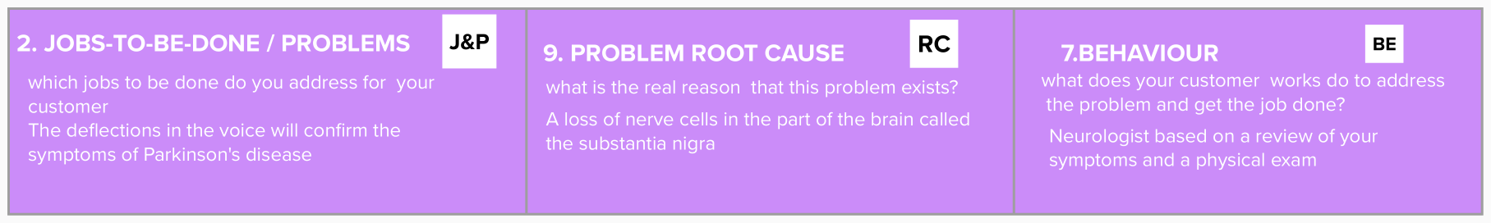

| **Identify strong TR & EM** | **3. TRIGGERS TR**  What triggers customers to act?  Curing from the disease trigger customer | **10. YOUR SOLUTION SL**  If you are working on an existing business, write down your current solution ﬁrst, ﬁll in the canvas, and check how much it ﬁts reality.  In this Python Machine learning project, we will build a model using which we can accurately detect the presence of Parkinson’s disease in one’s body. | 1. **CHANNELS of BEHAVIOUR CH**     1. **ONLINE**   What kind of actions do customers take online? Extract online channels from #7  time to answer cost-effective **actions**.   * 1. **OFFLINE**   What kind of actions do customers take ofﬂine? Extract ofﬂine channels from #7 and use them for customer development. |  |
| --- | --- | --- | --- | --- |
| **4. EMOTIONS: BEFORE / AFTER EM**  How do customers feel when they face a problem or a job and afterwards?  Trust,happy,greatfull etc… |

